**A picture containing clipart

Description generated with very high confidence**

Installing Kubernetes Dashboard

DevOps Certification Training

[**support@intellipaat.com**](mailto:support@intellipaat.com)

**+91-7022374614**

**US: 1-800-216-8930(Toll Free)**

**INSTALLING KUBERNETES DASHBOARD**

**Steps for Master**

**Step 1:** For installing Kubernetes Dashboard, run the following command:

$ kubectl create -f https://raw.githubusercontent.com/kubernetes/dashboard/master/aio/deploy/recommended/kubernetes-dashboard.yaml

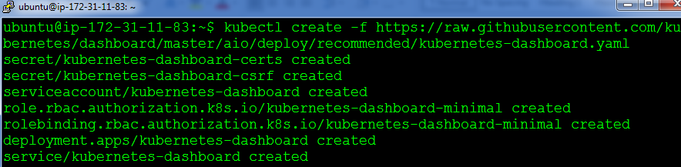

**Step 2:** Edit the Kubernetes Dashboard service with this command

$ kubectl edit svc kubernetes-dashboard –n kube-system

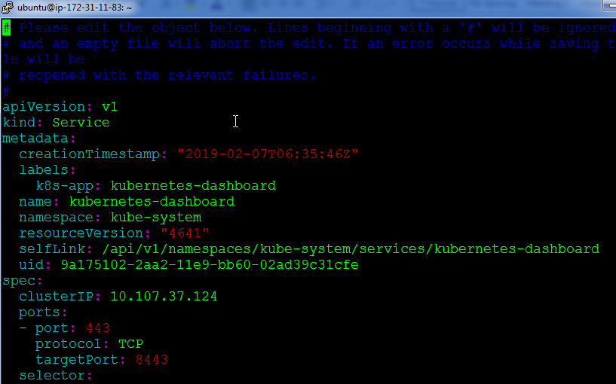

**Step 3:** Change the text “clusterip” to “nodeport”, once done save and exit.

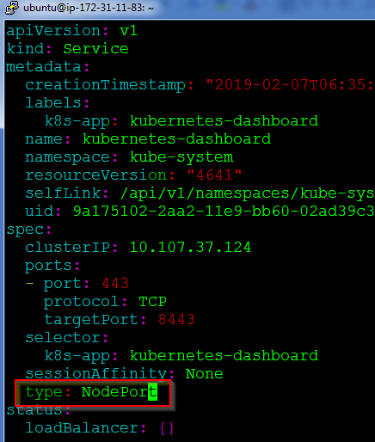

**Step 4:** Finally note down the IP address of the kubernetes-dashboard service using the following command:

$ kubectl get svc kubernetes-dashboard –n kube-system

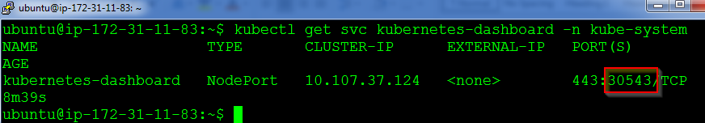

**Step 5:** Next browse, to the following address, to the see the login page of the dashboard:

https://<ip-address-of-master-or-slave:<nodeport>

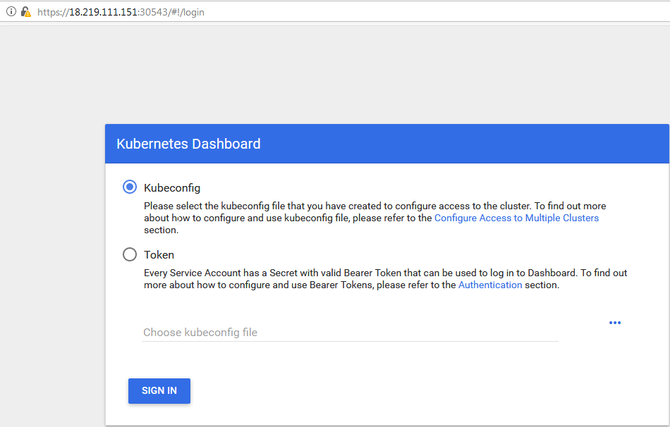

**Step 6:** For logging in , use the following commands:

# Create service account

kubectl create serviceaccount cluster-admin-dashboard-sa

# Bind ClusterAdmin role to the service account

kubectl create clusterrolebinding cluster-admin-dashboard-sa \

--clusterrole=cluster-admin \

--serviceaccount=default:cluster-admin-dashboard-sa

# Parse the token

TOKEN=$(kubectl describe secret $(kubectl -n kube-system get secret | awk '/^cluster-admin-dashboard-sa-token-/{print $1}') | awk '$1=="token:"{print $2}')

**Step 7:** Now pass the following command, to view the token:

echo $TOKEN

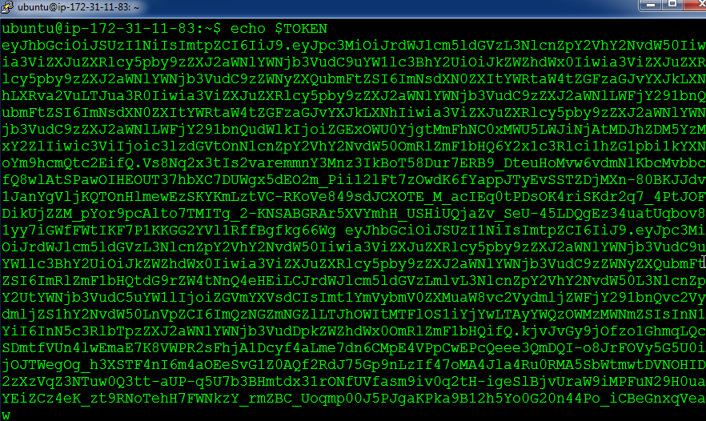

**Step 8:** Copy this token and paste it in the login page of Kubernetes Dashboard:

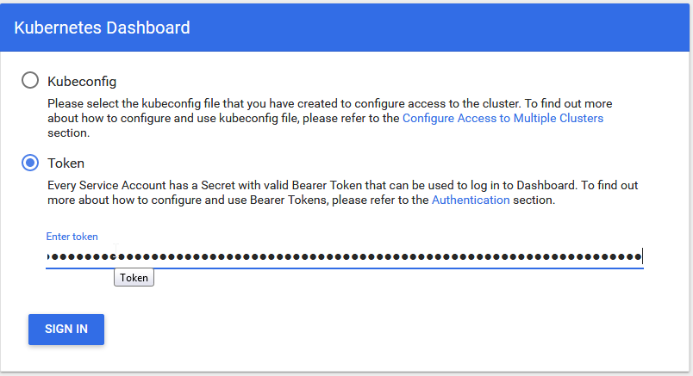

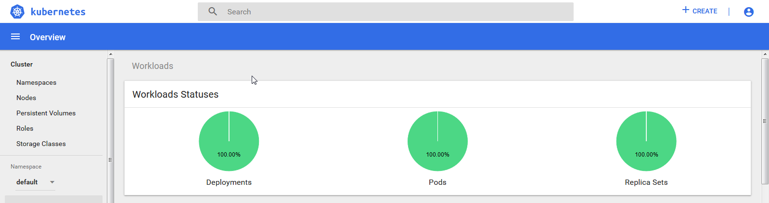

Kubernetes Dashboard is now successfully installed!